**Project 1**

**Administrating VPC and EC2 services by launching Linux servers under Elastic load balancing rules under defined subnetworks with autoscaling method**

**Below are the services used for the assignment:**

**VPC:** Amazon Virtual Private Cloud (Amazon VPC) enables you to launch AWS resources into a virtual network that you've defined. This virtual network closely resembles a traditional network that you'd operate in your own data center, with the benefits of using the scalable infrastructure of AWS.

**Subnet**: A [subnet](https://docs.aws.amazon.com/vpc/latest/userguide/configure-subnets.html) is a range of IP addresses in your VPC. A subnet must reside in a single Availability Zone. After you add subnets, you can deploy AWS resources in your VPC.

**Availability Zones**: Availability Zones are distinct locations within an AWS Region that are engineered to be isolated from failures in other Availability Zones. They provide inexpensive, low-latency network connectivity to other Availability Zones in the same AWS Region. Each region is completely independent.

**Internet Gateway:** An internet gateway is a horizontally scaled, redundant, and highly available VPC component that allows communication between your VPC and the internet. It supports IPv4 and IPv6 traffic. It does not cause availability risks or bandwidth constraints on your network traffic.

An internet gateway enables resources in your public subnets (such as EC2 instances) to connect to the internet if the resource has a public IPv4 address or an IPv6 address. Similarly, resources on the internet can initiate a connection to resources in your subnet using the public IPv4 address or IPv6 address. For example, an internet gateway enables you to connect to an EC2 instance in AWS using your local computer.

An internet gateway provides a target in your VPC route tables for internet-routable traffic. For communication using IPv4, the internet gateway also performs network address translation (NAT). For communication using IPv6, NAT is not needed because IPv6 addresses are public. For more information, see [IP addresses and NAT](https://docs.aws.amazon.com/vpc/latest/userguide/VPC_Internet_Gateway.html#ip-addresses-and-nat).

**Security Group**: **A security group controls the traffic that is allowed to reach and leave the resources that it is associated with.** For example, after you associate a security group with an EC2 instance, it controls the inbound and outbound traffic for the instance.

When you create a VPC, it comes with a default security group. You can create additional security groups for each VPC. You can associate a security group only with resources in the VPC for which it is created.

For each security group, you add rules that control the traffic based on protocols and port numbers. There are separate sets of rules for inbound traffic and outbound traffic.

**EC2**: **Amazon Elastic Compute Cloud (Amazon EC2) provides scalable computing capacity in the Amazon Web Services (AWS) Cloud.** Using Amazon EC2 eliminates your need to invest in hardware up front, so you can develop and deploy applications faster. You can use Amazon EC2 to launch as many or as few virtual servers as you need, configure security and networking, and manage storage. Amazon EC2 enables you to scale up or down to handle changes in requirements or spikes in popularity, reducing your need to forecast traffic.

**Target Group**: **Each target group is used to route requests to one or more registered targets.** When you create each listener rule, you specify a target group and conditions. When a rule condition is met, traffic is forwarded to the corresponding target group. You can create different target groups for different types of requests. For example, create one target group for general requests and other target groups for requests to the microservices for your application.

**Load Balancer**: A load balancer serves as the single point of contact for clients. The load balancer distributes incoming application traffic across multiple targets, such as EC2 instances, in multiple Availability Zones. This increases the availability of your application. You add one or more listeners to your load balancer.

**Launch Configuration**: A launch configuration is **an instance configuration template that an Auto Scaling group uses to launch EC2 instances**. When you create a launch configuration, you specify information for the instances.

Auto Scaling Group: An Auto Scaling group **contains a collection of EC2 instances that are treated as a logical grouping for the purposes of automatic scaling and management**. An Auto Scaling group also lets you use Amazon EC2 Auto Scaling features such as health check replacements and scaling policies.

Below are the steps, taken to execute the assignment:

1. Go to VPC dashboard, click on ‘Create VPC’

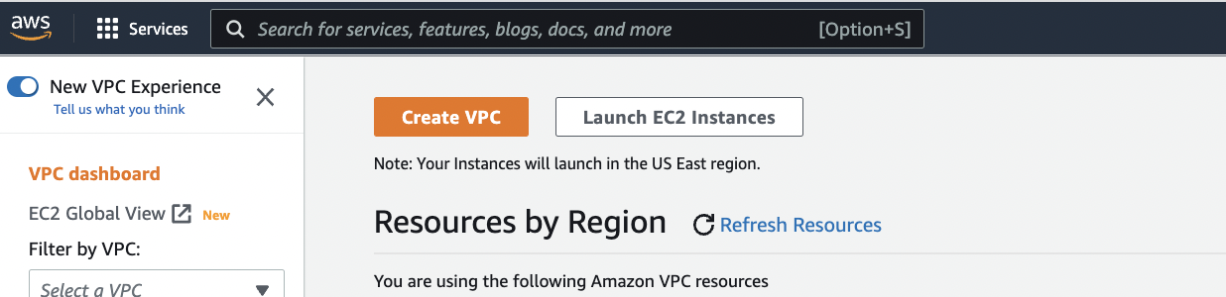

1. Configured below properties for creating a VPC with 2 public subnets
2. Resource to create – VPC and more
3. Name tag auto-generation – Enable ‘Auto-generate’
4. Number of Availability Zones – 2
5. Number of Public subnets – 2
6. Number of Private Subnets – 0
7. NAT gateways – None
8. VPC endpoints - None

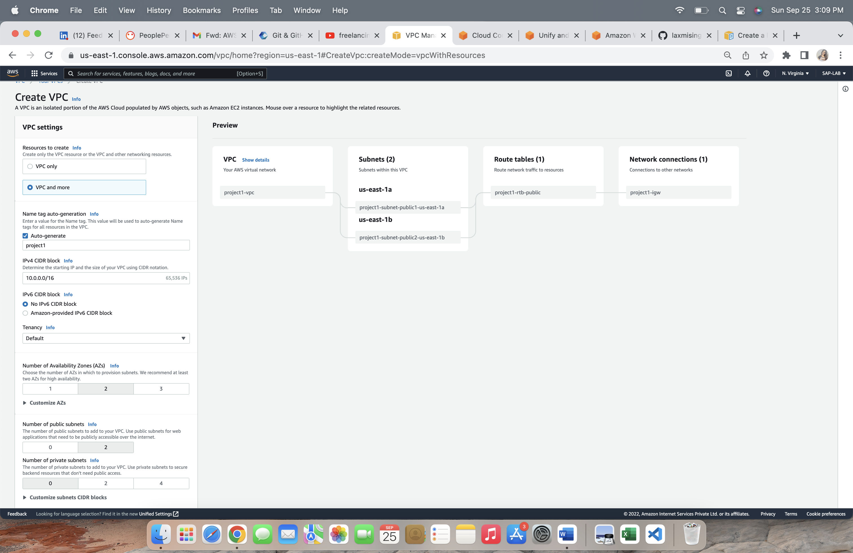

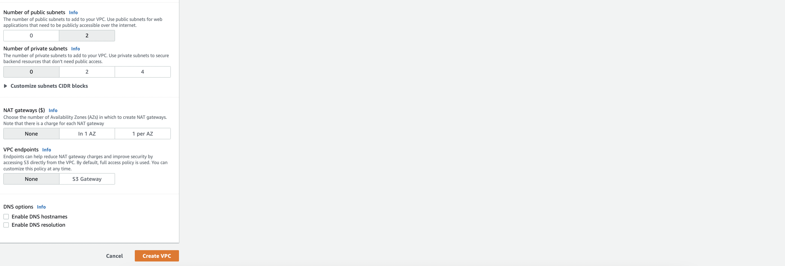

After successful creation of VPC we can check the same in VPC dashboard.

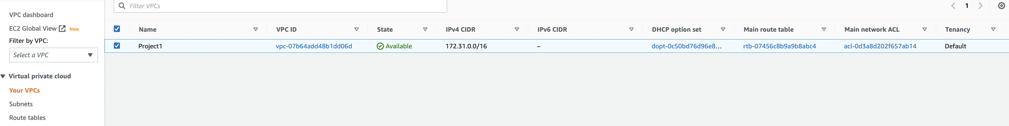

1. Create Internet gateway – Go to VPC dashboard Click on ‘Internet Gateway’ and create internet gateway, put the name ‘Project1_ig’.

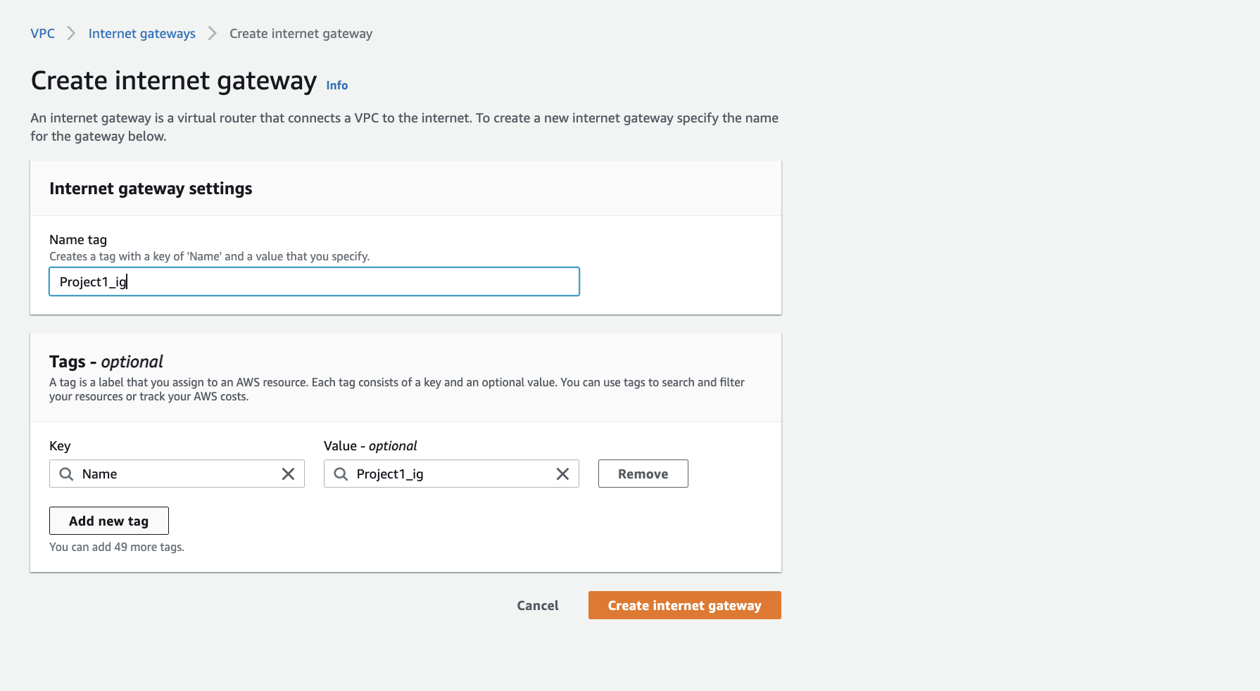

1. After creation of internet gateway attach it to VPC, we have created in above steps.

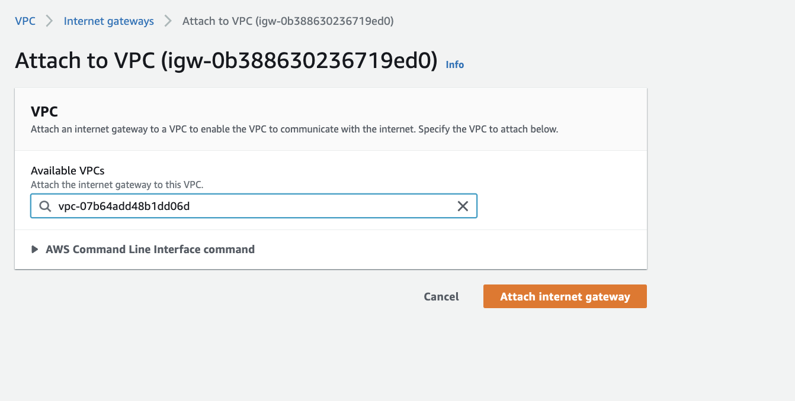

1. Create Security Group: On ‘EC2’ dashboard in ‘Security Groups’ under ‘Network & Security’ click on ‘Create Security Group’



Configured below properties for SecurityGroup

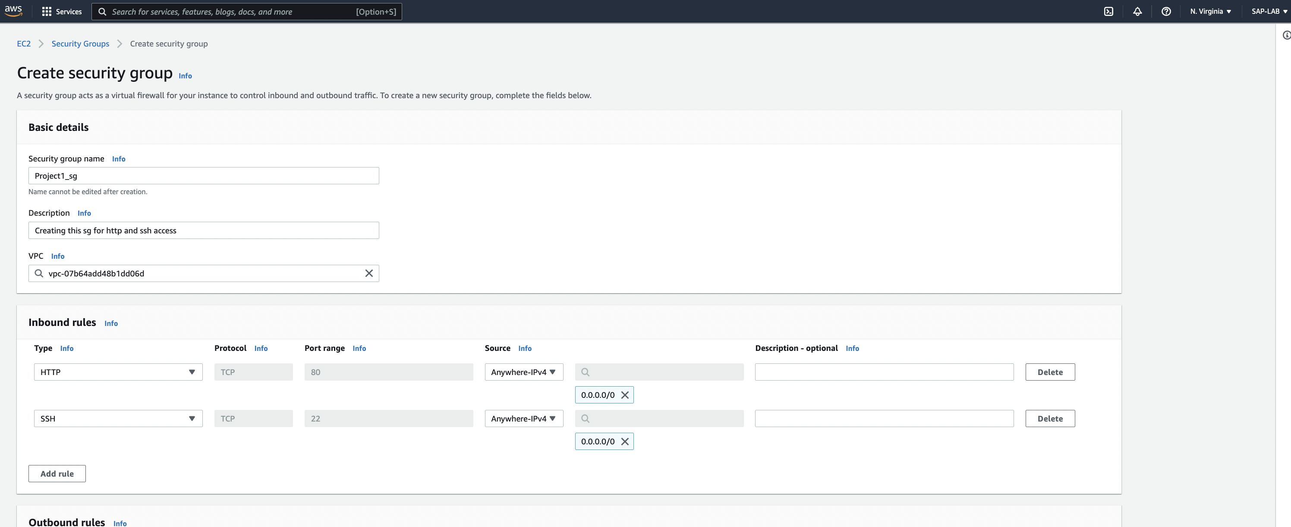

Click on ‘Create Security Group’.

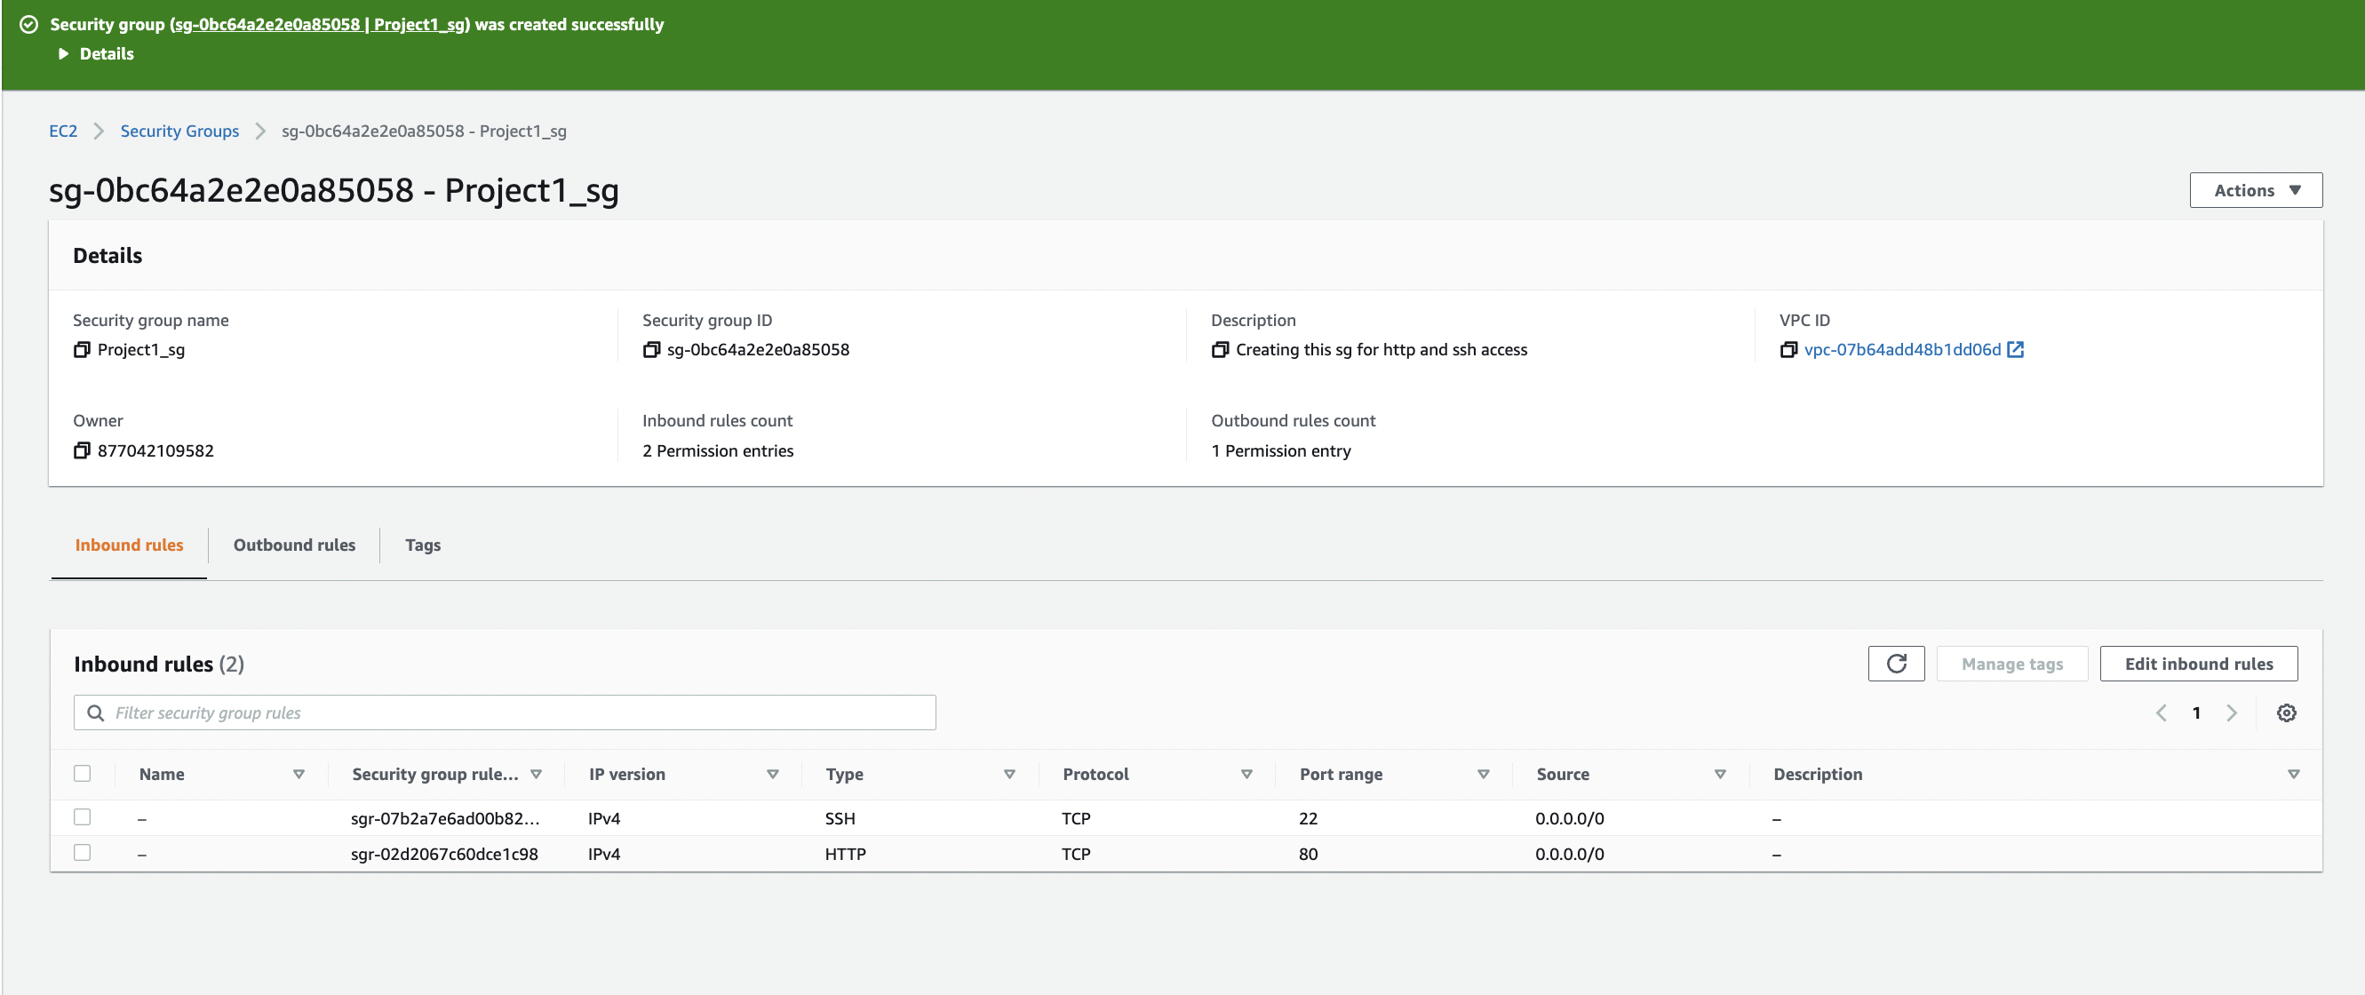

1. Create EC2 instance in 2 different AZs
2. Click on ‘Launch Instance’ on EC2 dashboard.

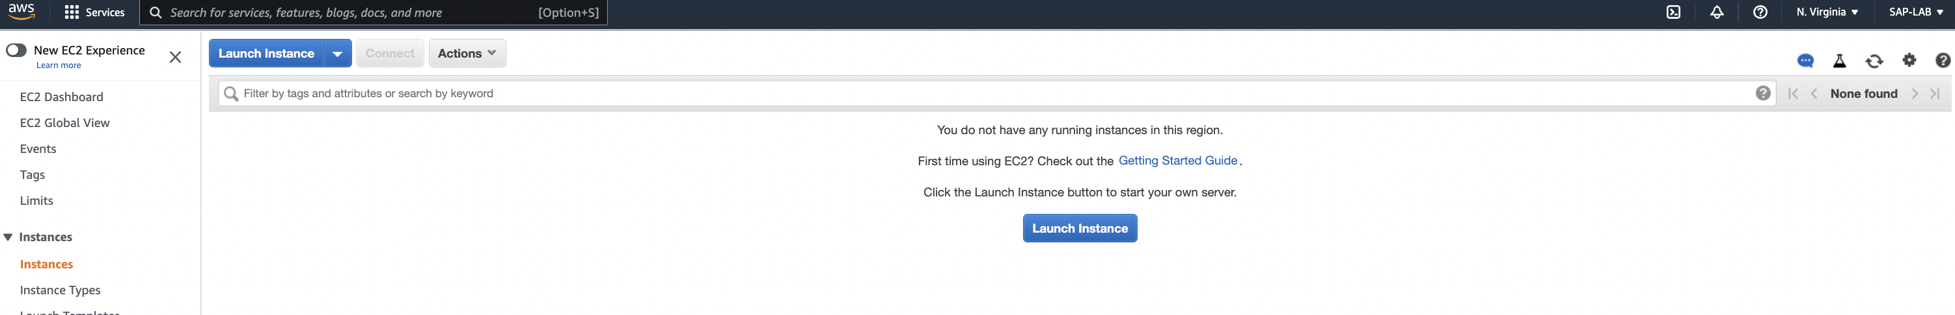

1. Configured below properties to ‘Launch Instance’:
   * 1. Name: Project_ec2_a
     2. AMI: It is already selected the AMI which is eligible for free tier.
     3. Instance Type: It also selects free tier instance type. As per the configuration we can add required instance.
     4. Key-Pair: Create a Key-pair and save it to desired place, it is useful to connect to EC2.
     5. Network Setting: Select the VPC, enable the ‘auto-assign’ public IP.
     6. Select the security group.
     7. Under advance Setting: Put the user data

#!/bin/bash

|  |
| --- |
| yum install httpd -y |
| service httpd start |
| instanceId=$(curl http://169.254.169.254/latest/meta-data/instance-id) |
| echo "<h1>Test1 $instanceId</h1>" > /var/www/html/index.html |

* + 1. Click on the ‘Launch Instance’.

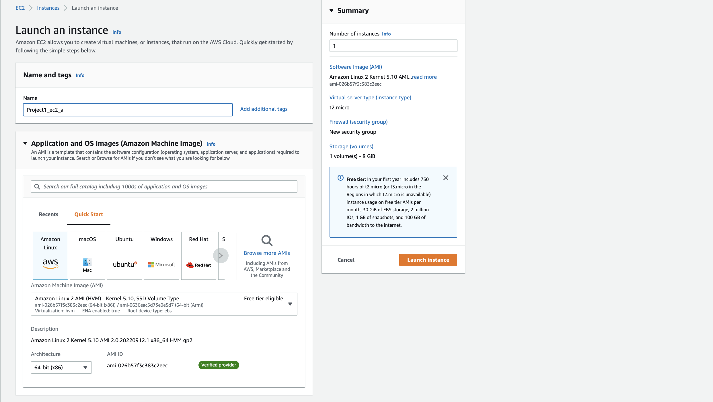

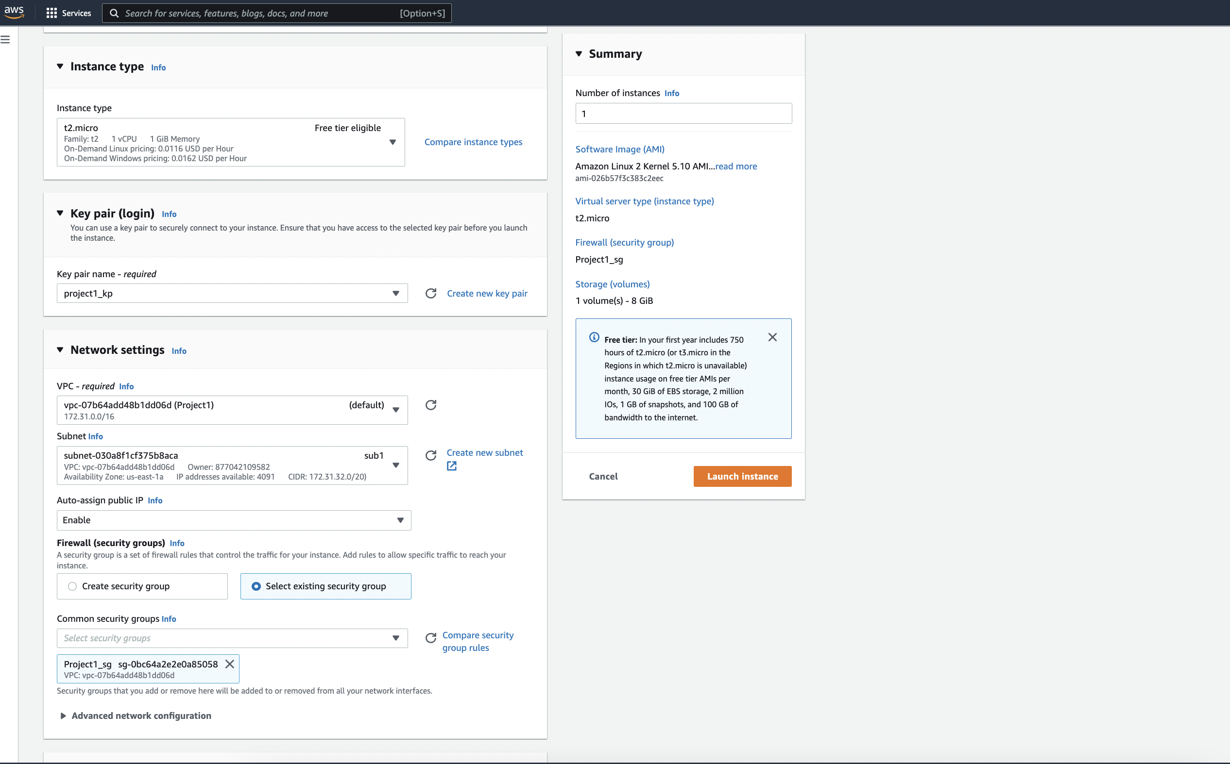

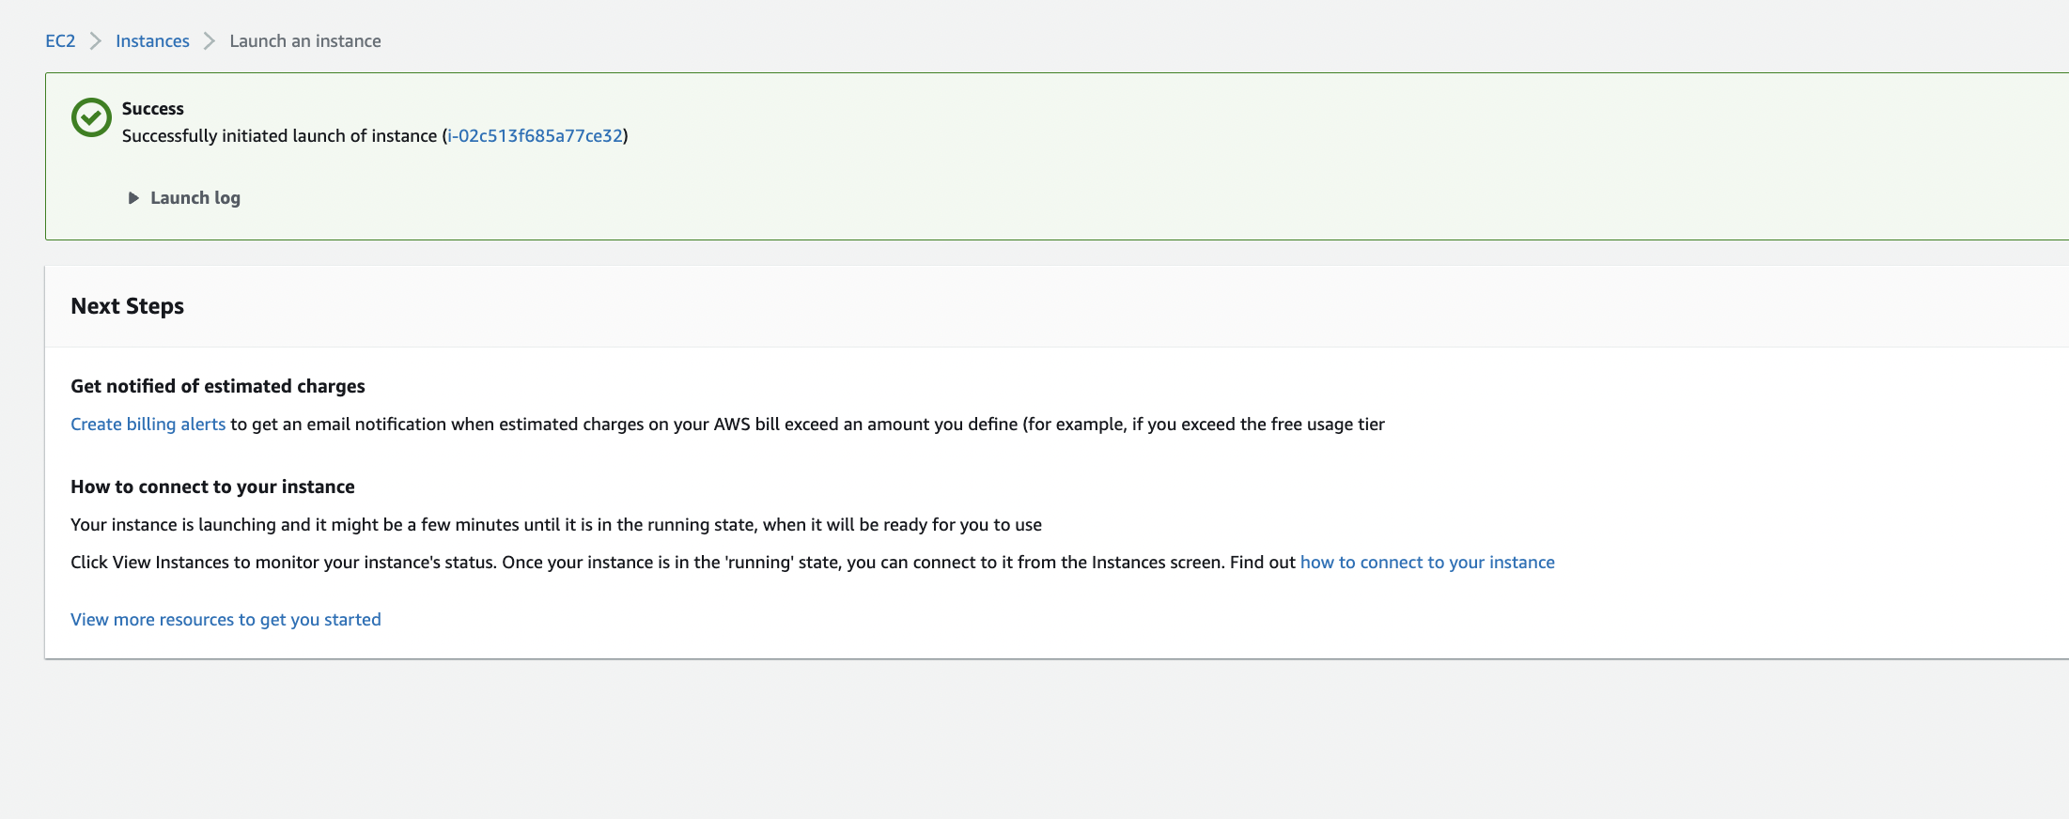

Create another Instance – Project1_ec2_b

Keep all the configuration similar for ec2, apart from Name. and use below user data:

#!/bin/bash

|  |
| --- |
| yum install httpd -y |
| service httpd start |
| instanceId=$(curl http://169.254.169.254/latest/meta-data/instance-id) |
| echo "<h1>Test2 $instanceId</h1>" > /var/www/html/index.html |

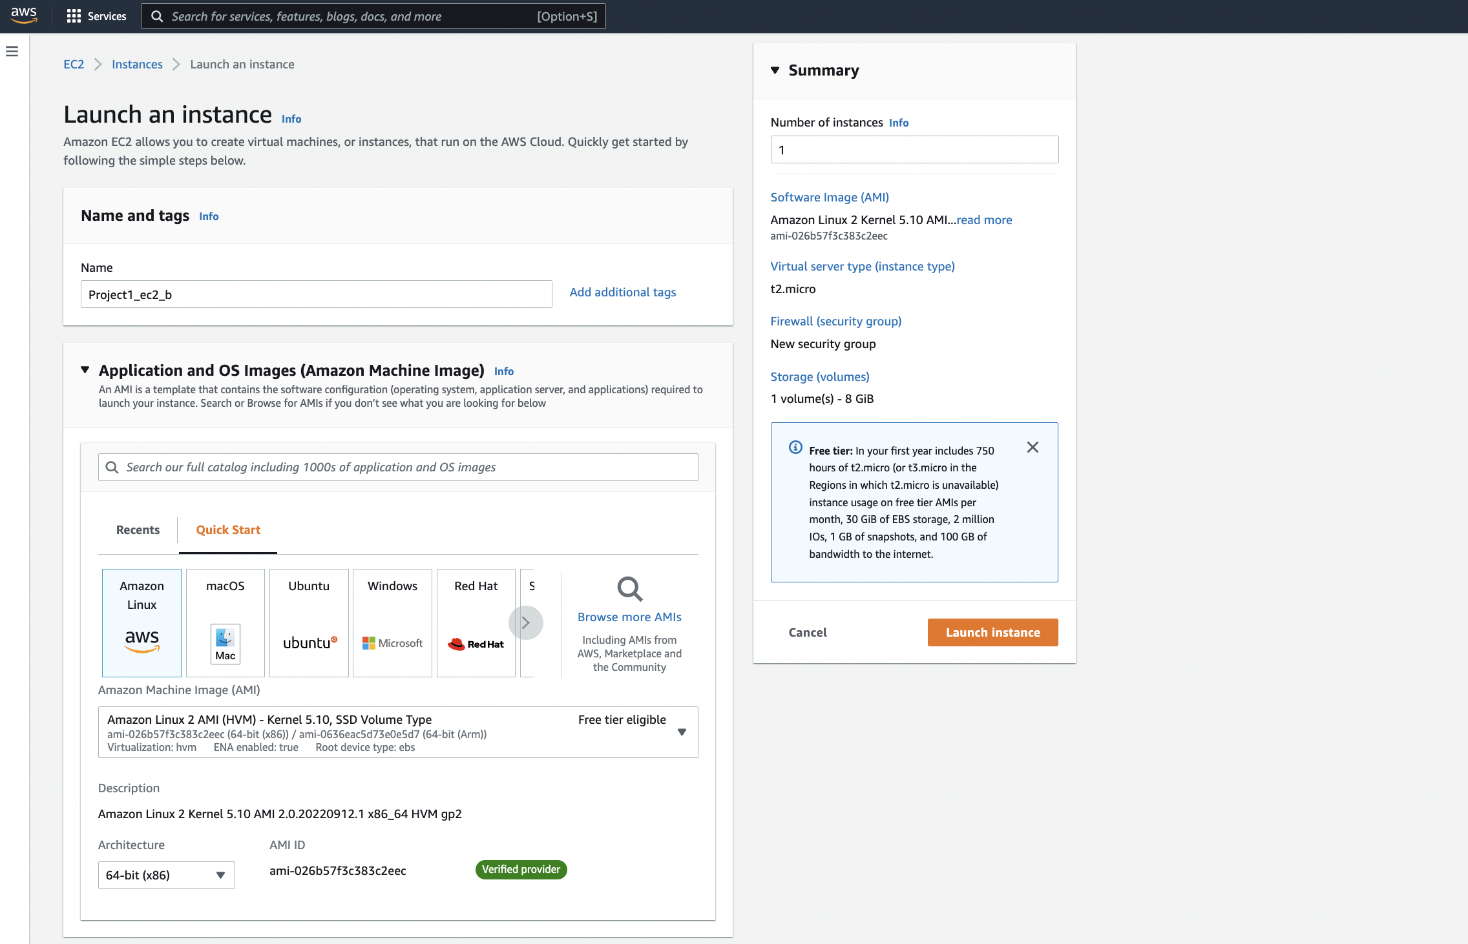

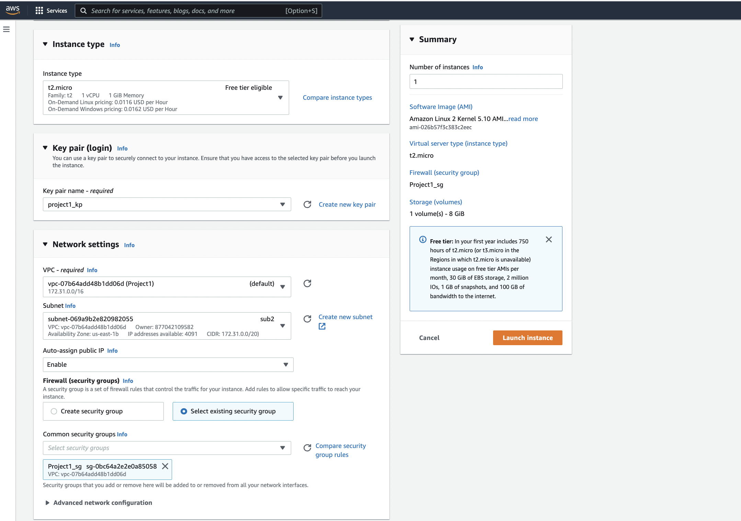

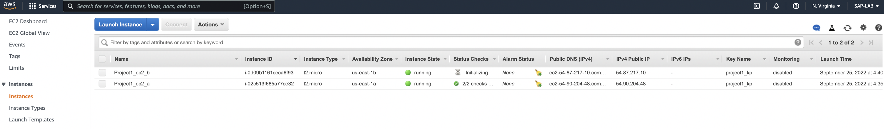

1. Create Target Group for Load Balancer

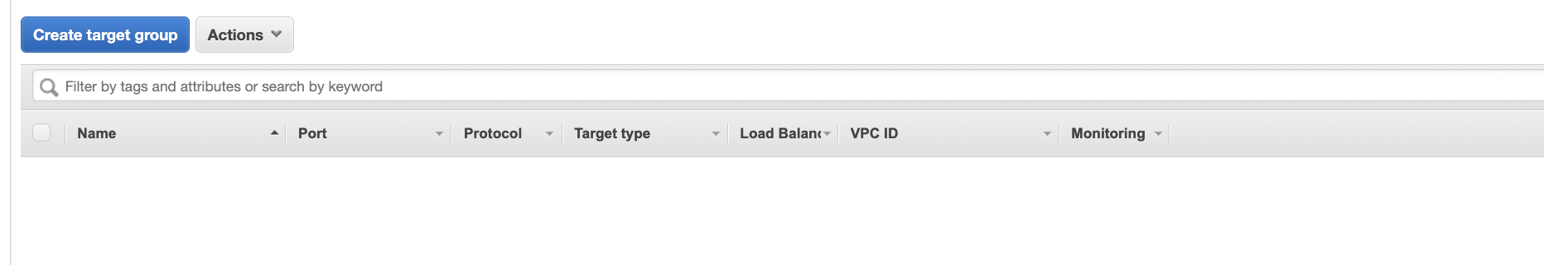

1. Configure the required details as below:
   1. Target Group Name: Project1-TG
   2. Target Type: Instance
   3. VPC: Select the VPC

Click on create.

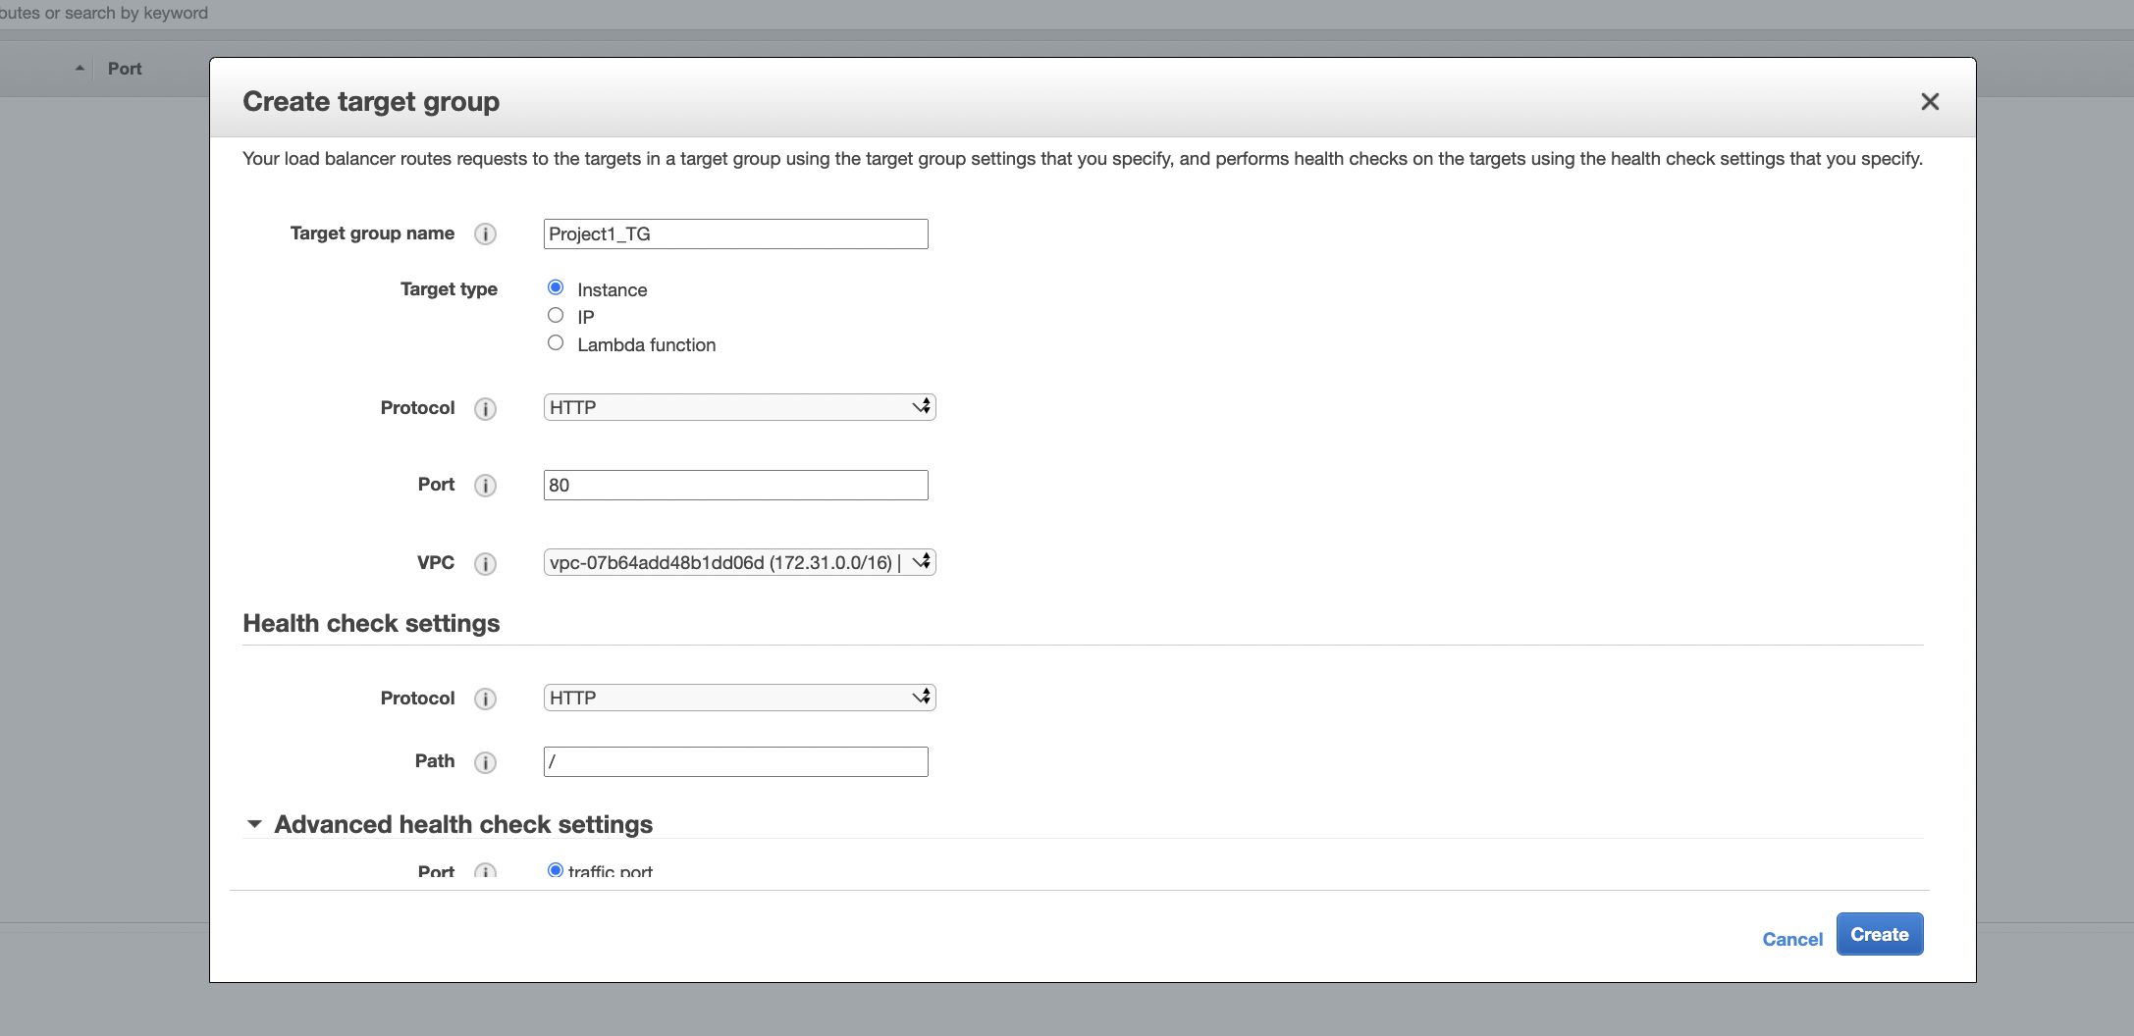

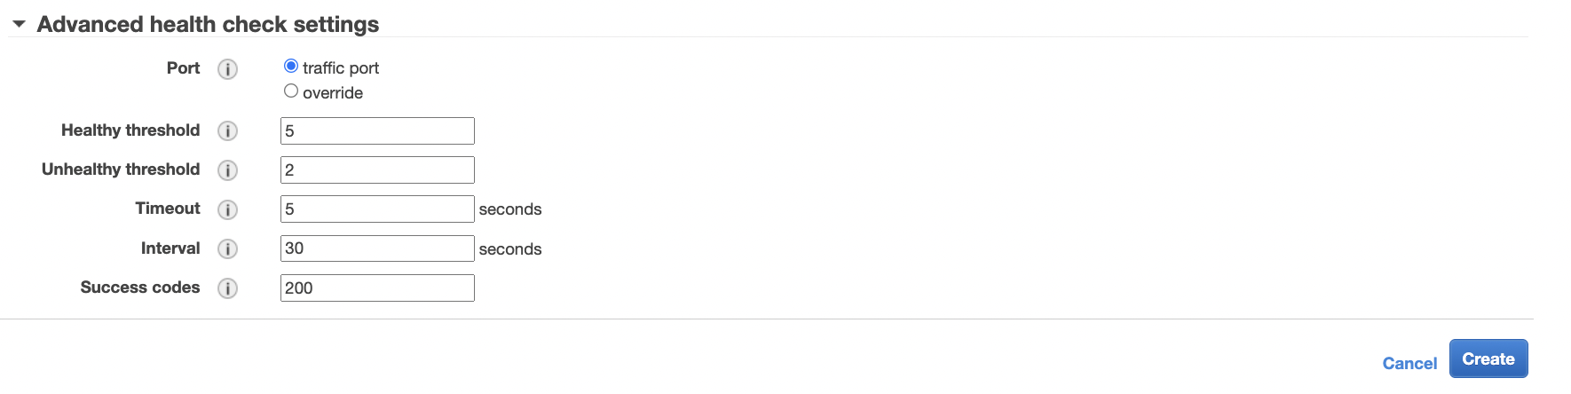

1. Add instance to target group

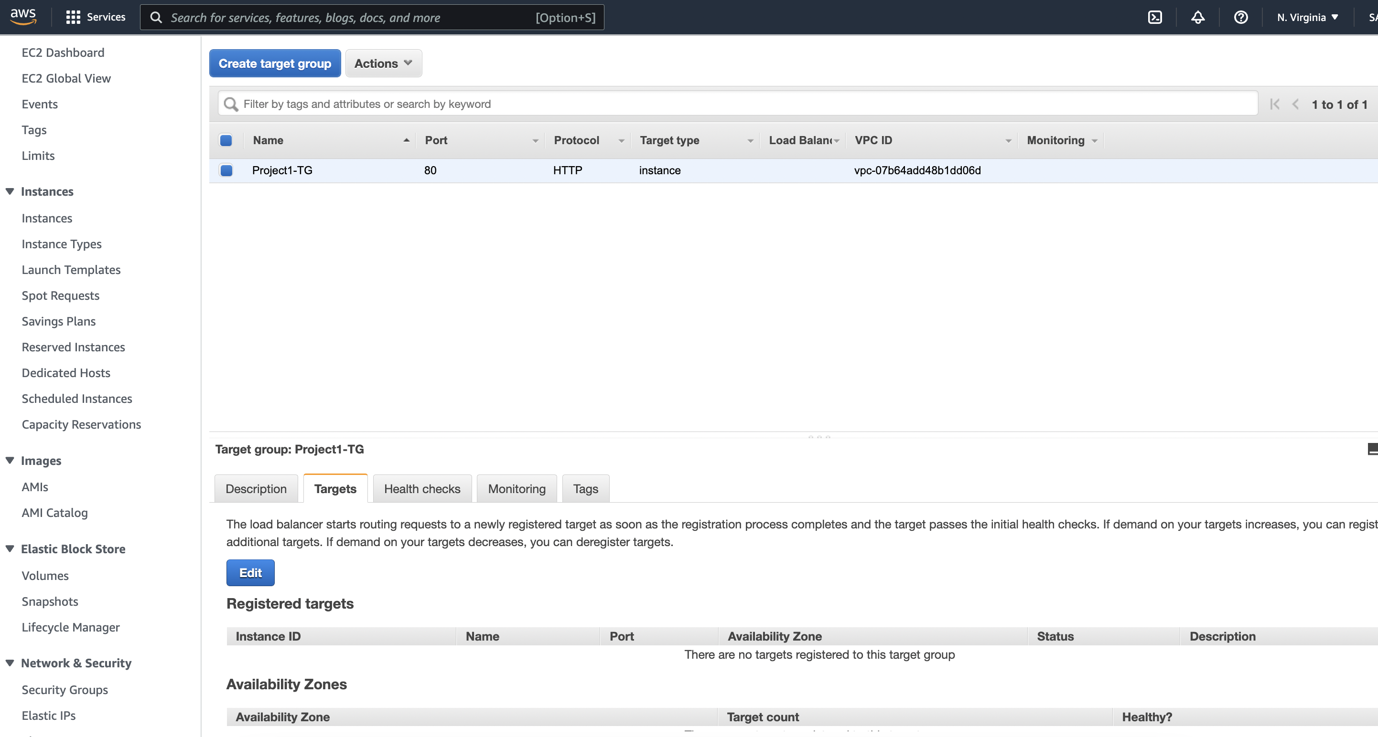

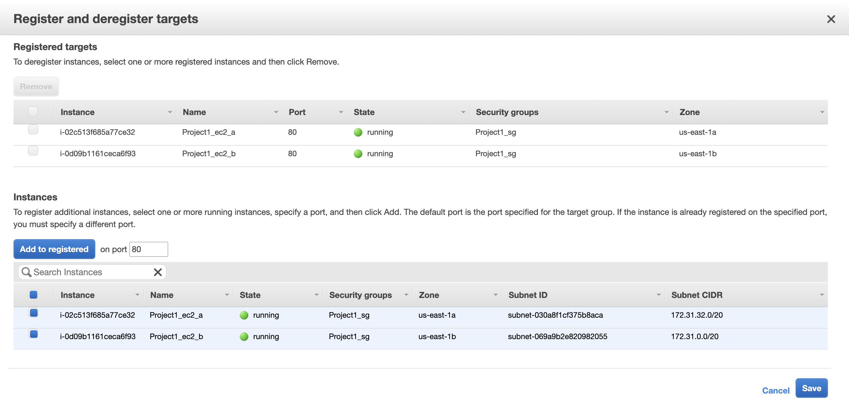

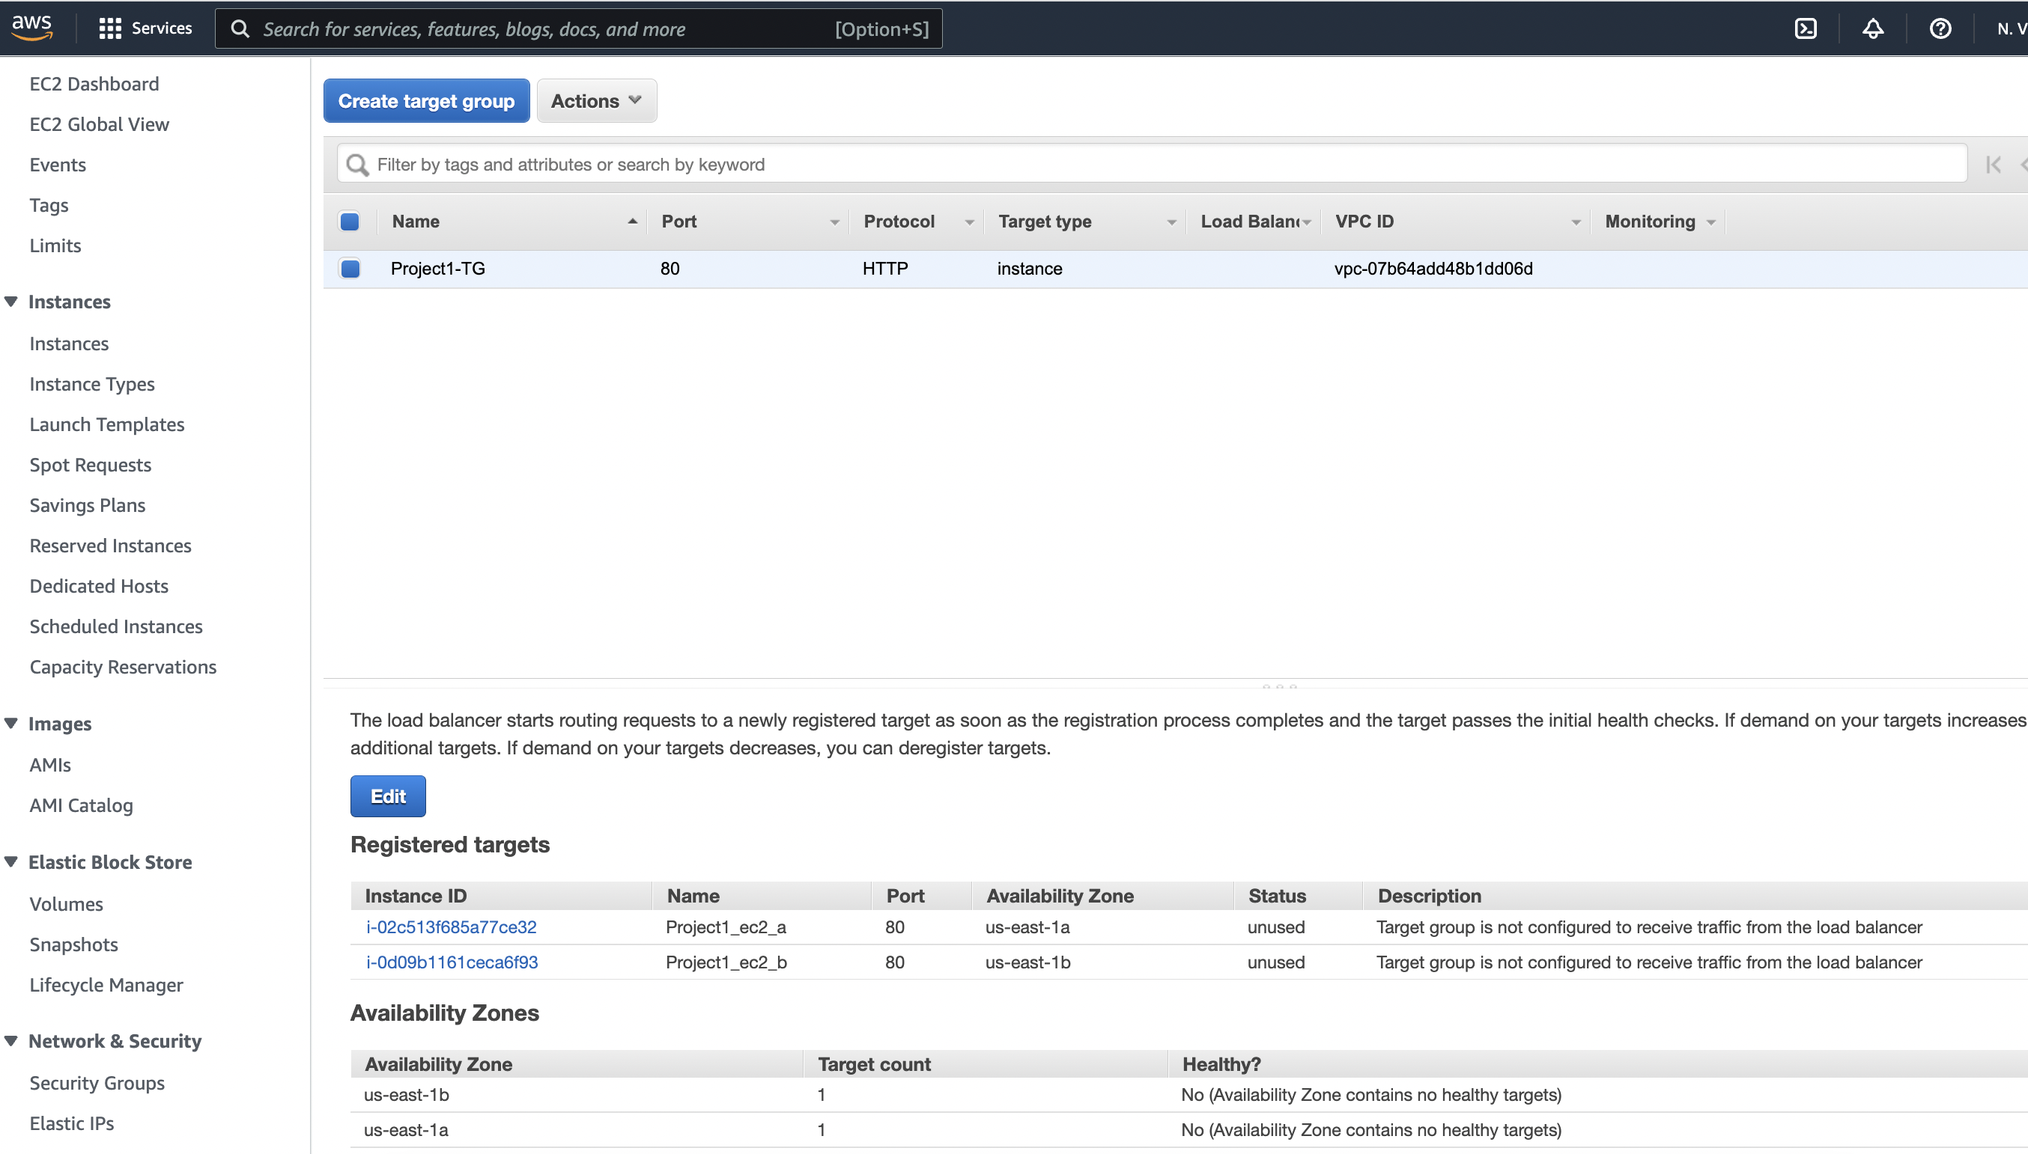

1. Create a Load balancer:
   1. Click on ‘Application Load Balancer’.

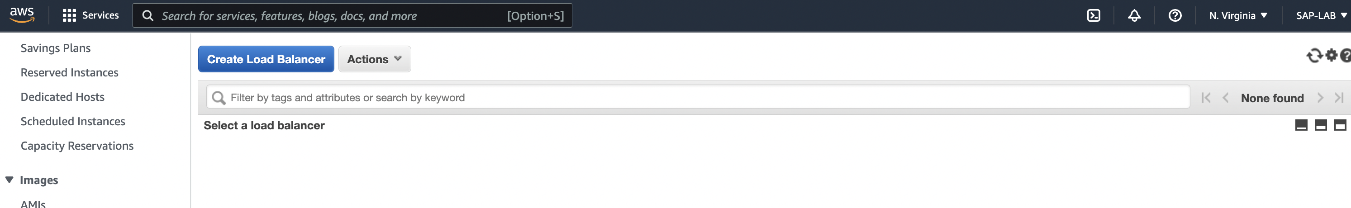

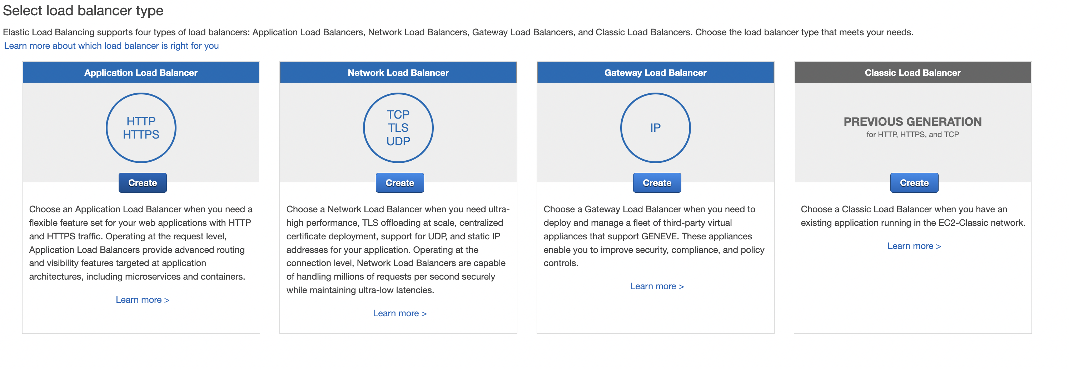

1. Configure the below properties for ‘Load Balancer’
   1. Name: Project-ALB1
   2. Scheme: Internet-facing
   3. IP-address type: Ipv4
   4. Availability Zones: Select the VPC and availability zones, in which we created our instances.

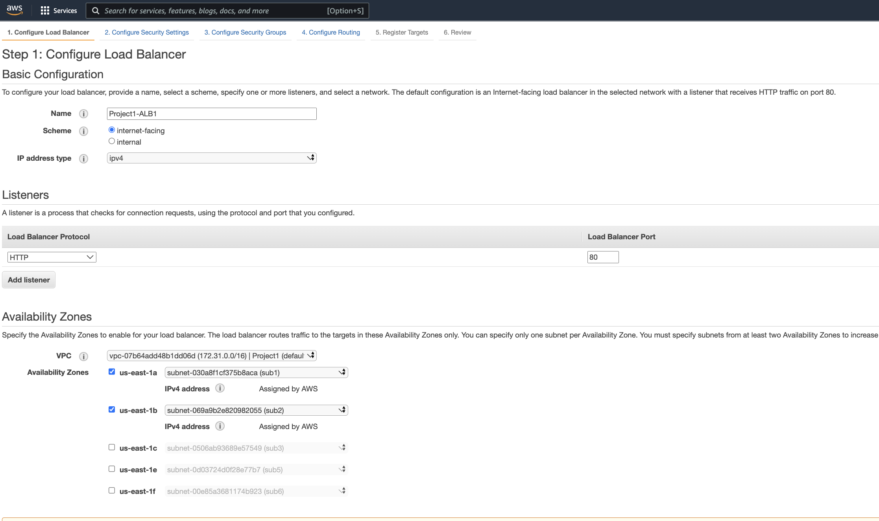

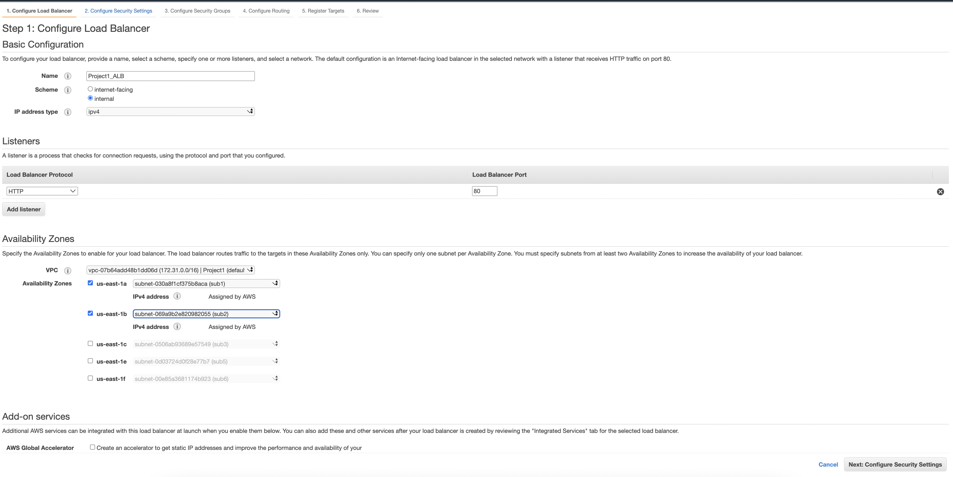

* 1. Select the security group.

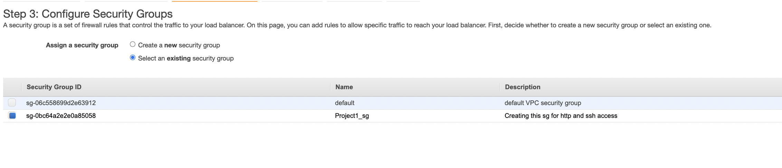

* 1. Select existing TG

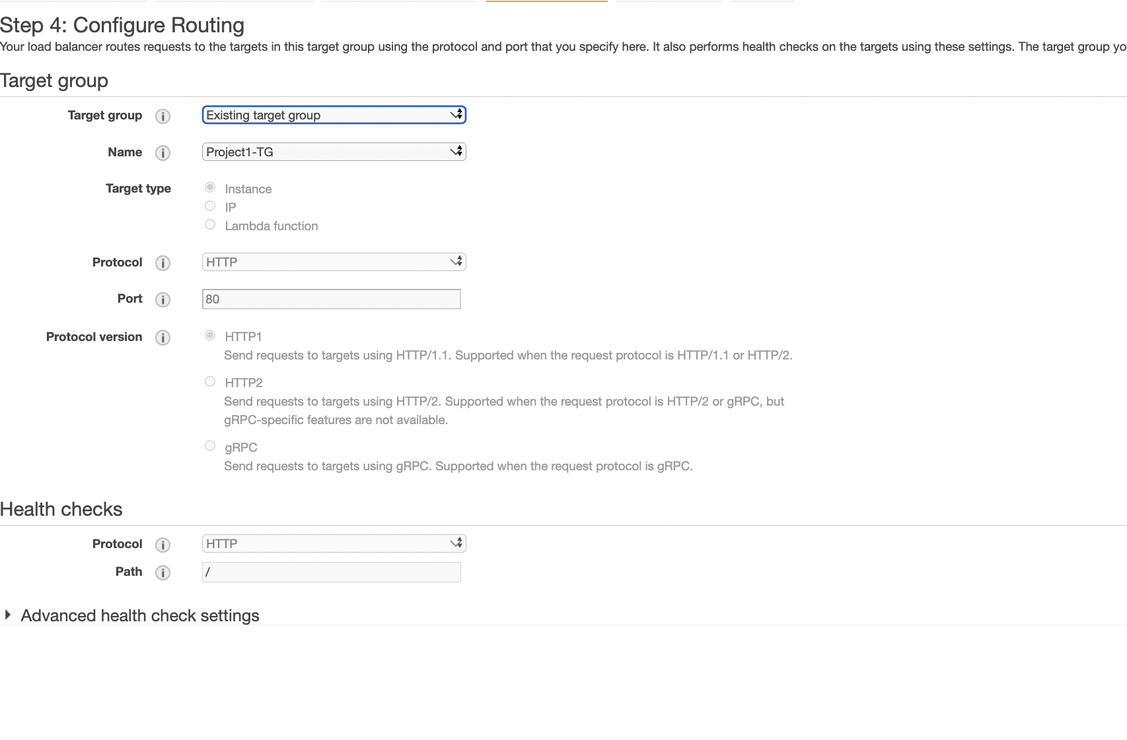

* 1. Re-check the registered Targets

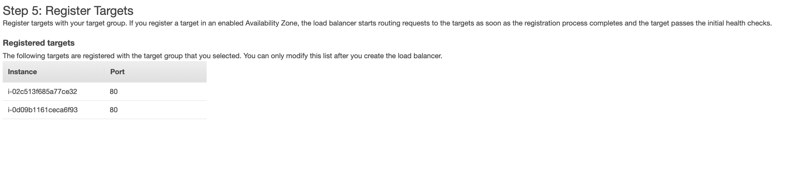

* 1. Review and click on create

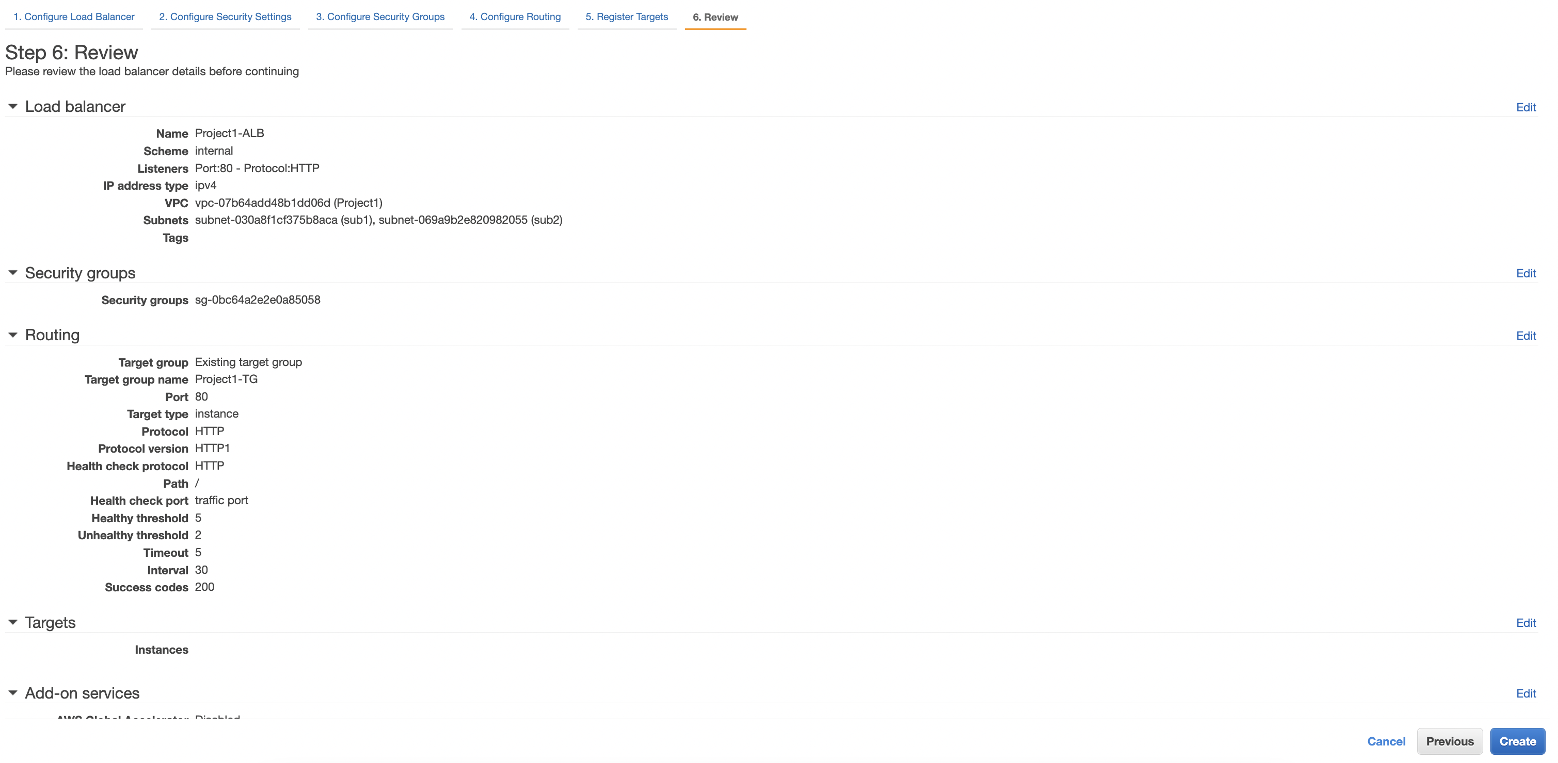

1. Under Auto-Scaling on EC2 dashboard, click on Launch Configuration

Click on ‘Create Launch Configuration’

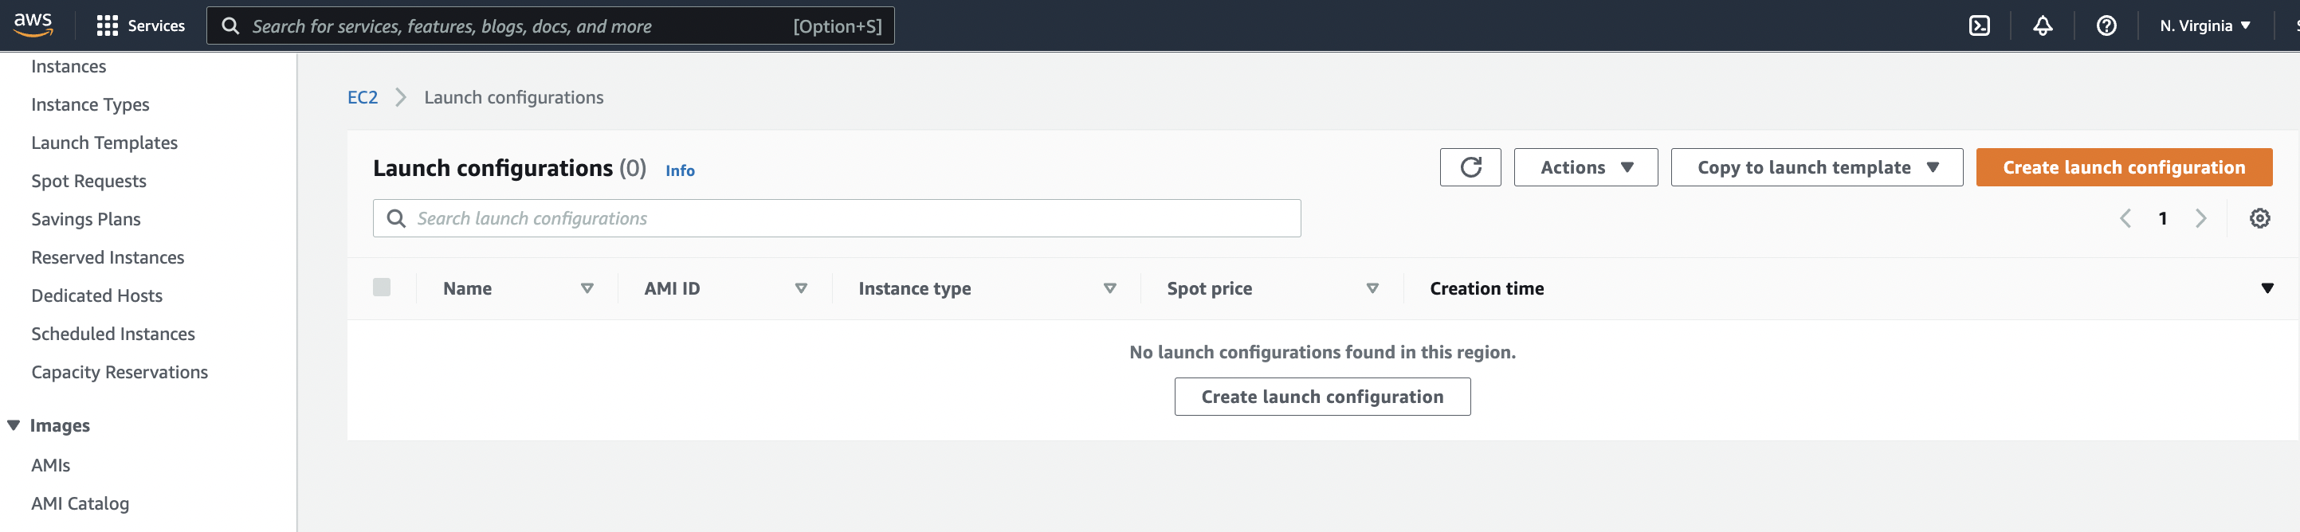

Configure below properties for ‘Launch Configuration’

* 1. Name: Project_LG
  2. AMI: Select the AMI to launch the new instance for auto-scaling
  3. Instance-type: Select the instance type for EC2
  4. Security Group: Select the security group.
  5. Key-pair: Create or select the already created Key-pair.

acknowledge and click on ‘create launch configuration’.

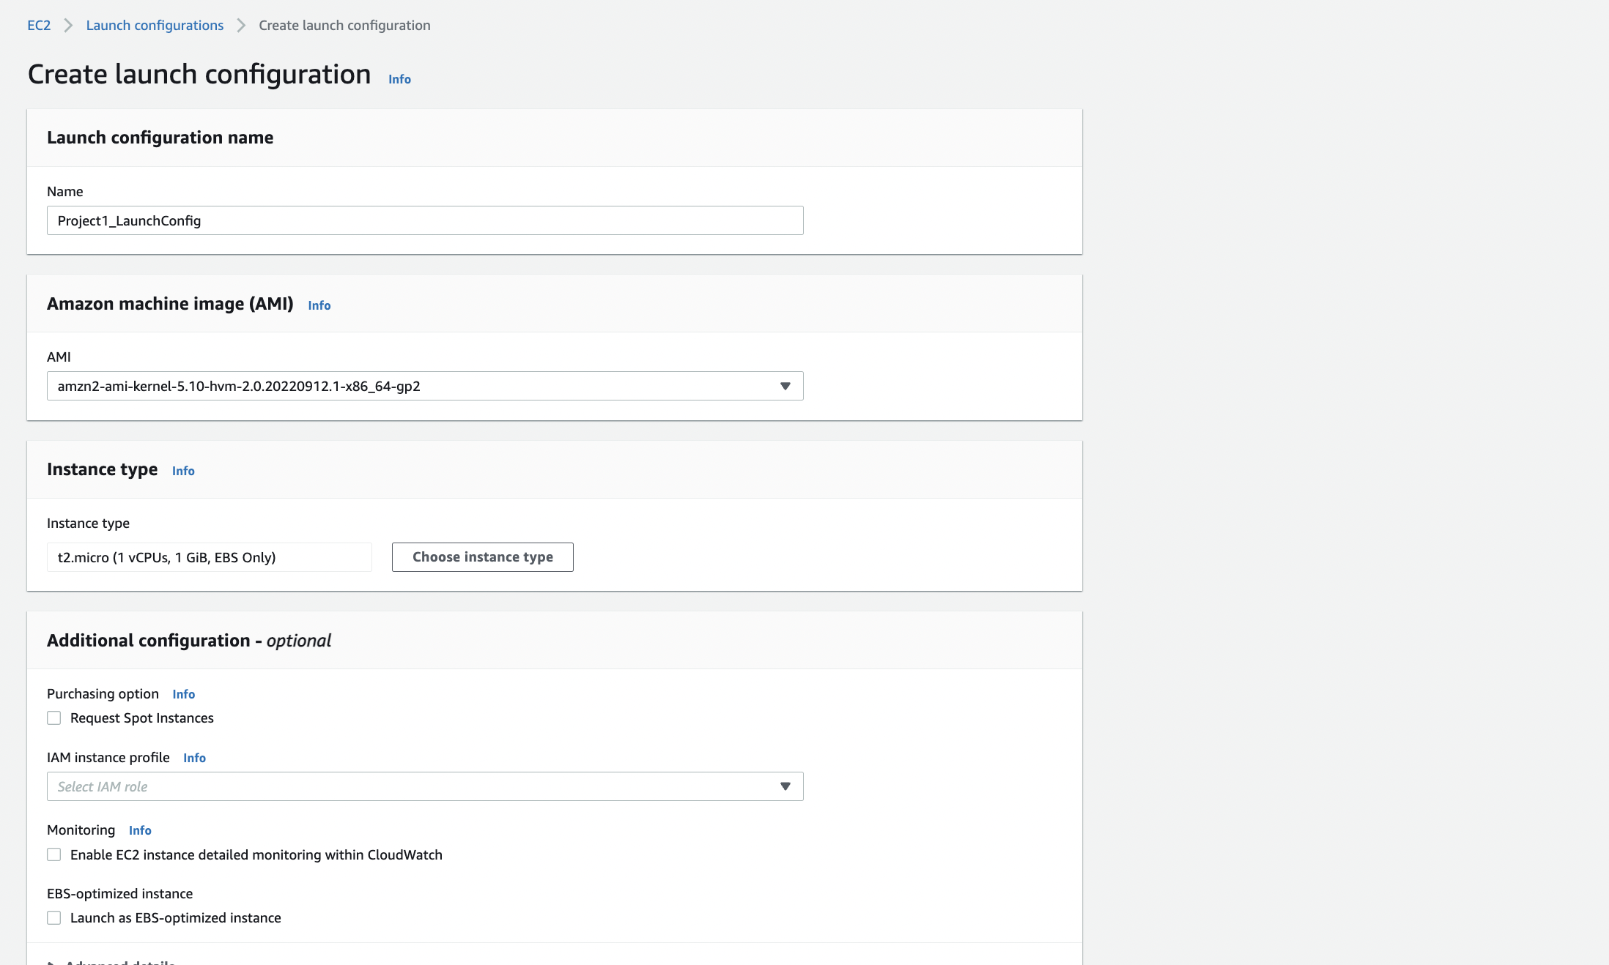

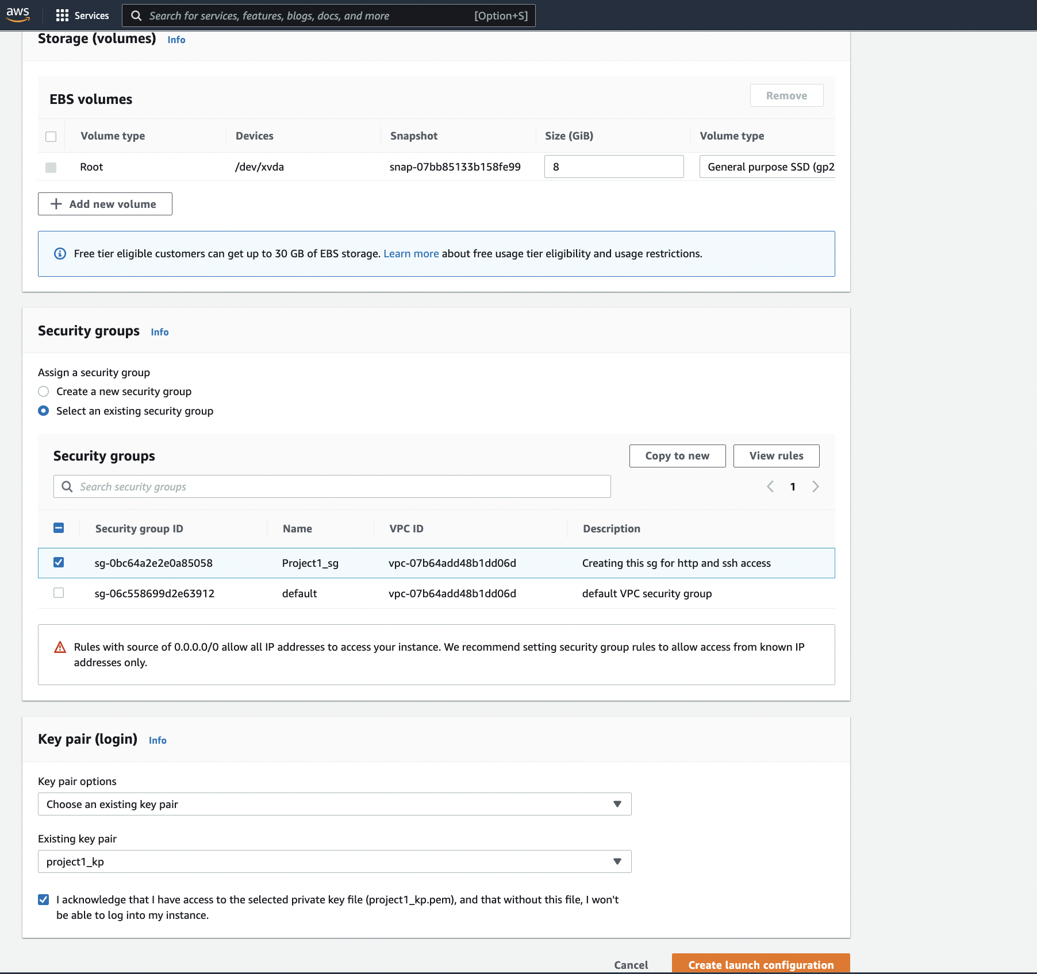

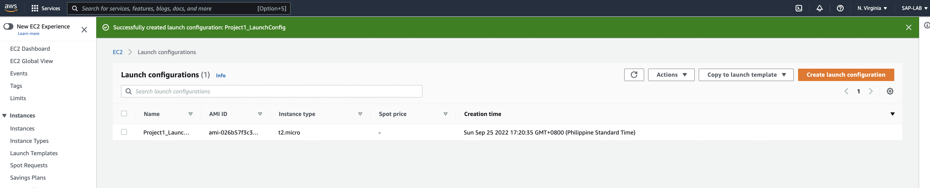

1. Create Auto Scaling group and attach ALB

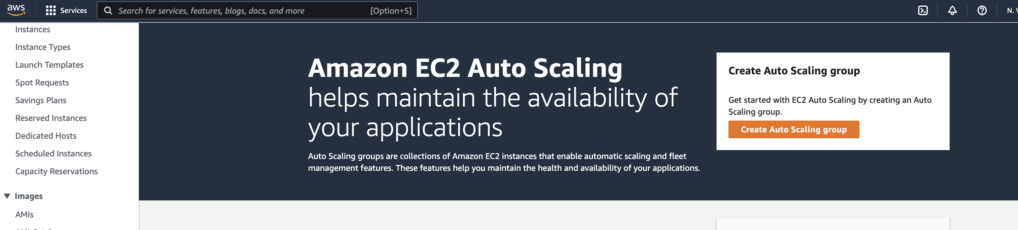

* 1. Switch to ‘Launch Configuration’ and select the ‘launch configuration’ and click on next.

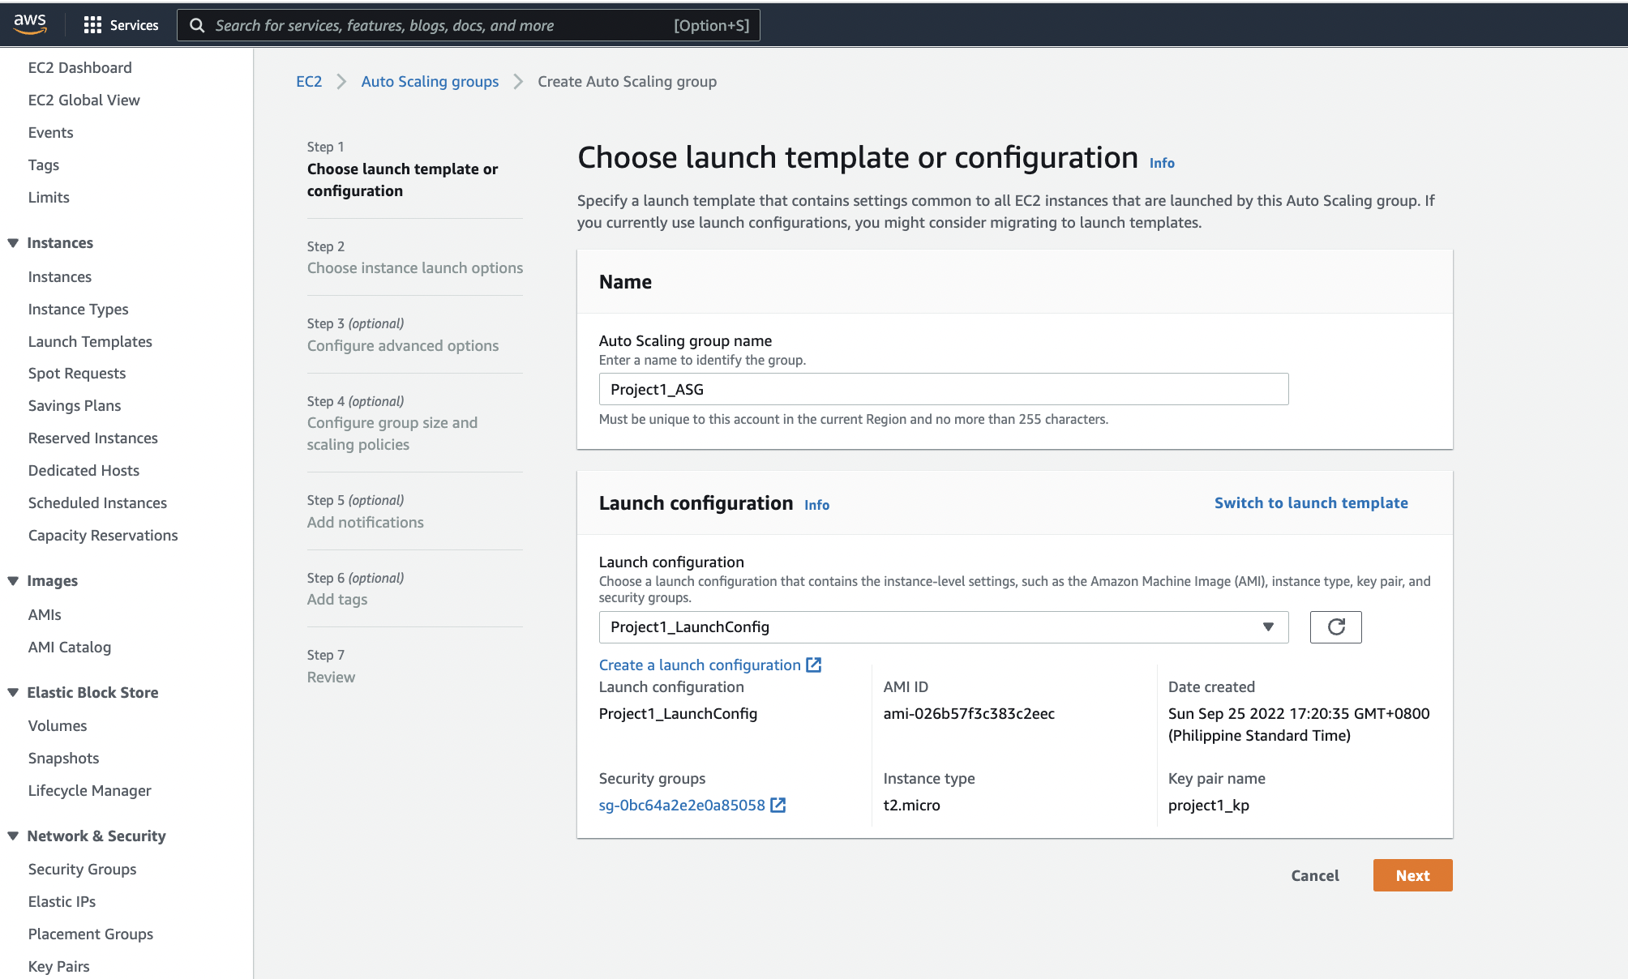

* 1. Under Network setting, choose the VPC and availability zones and click on next.

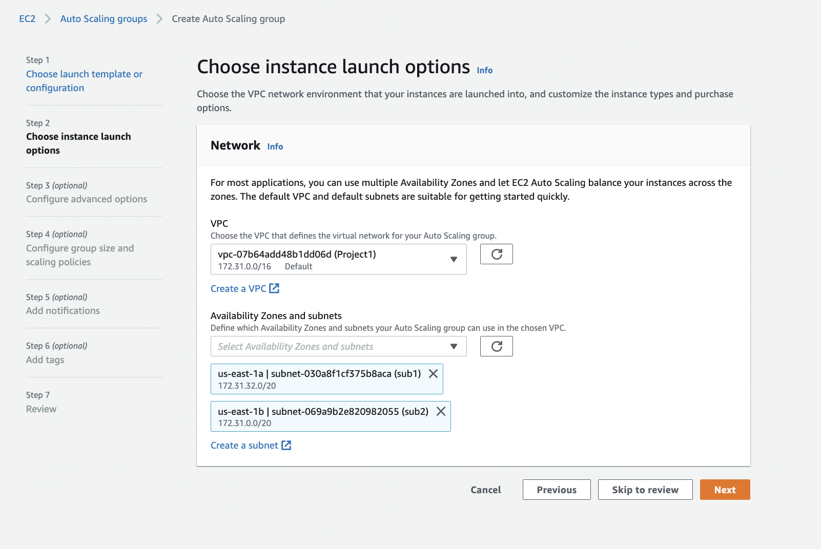

* 1. Under Group size and policy – Select the number of desired instance to be launched if load increases/instance terminated. define the minimum and maximum capacity and click on next.

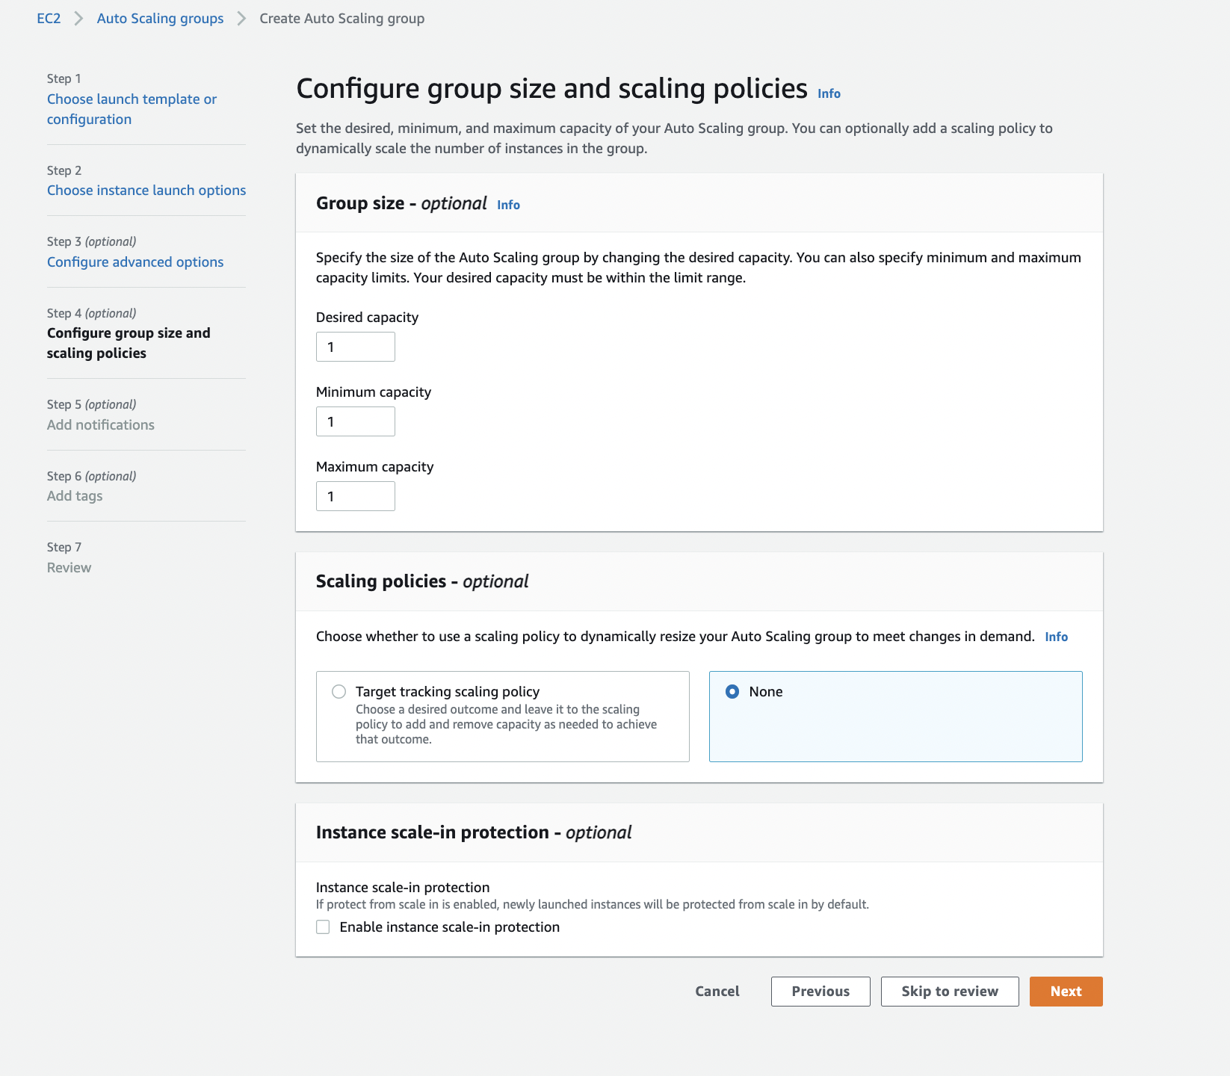

* 1. Review and click on ‘Create Auto scaling group’

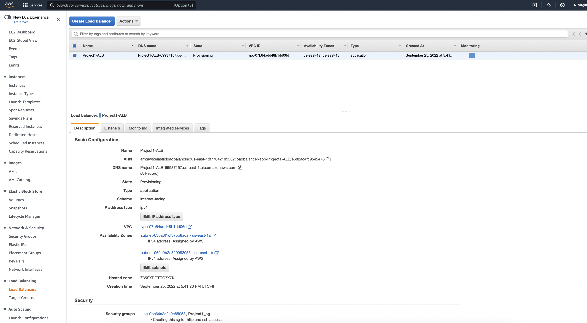

1. **Autoscaling Testing**

In below scenario, when we terminate the instance, a new instance getting launched with the same configuration we have made in ‘Launch Configuration’.

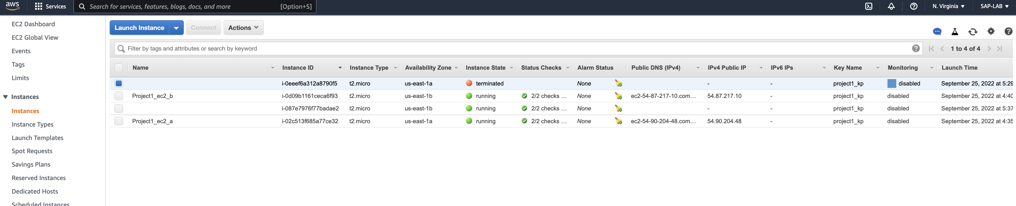

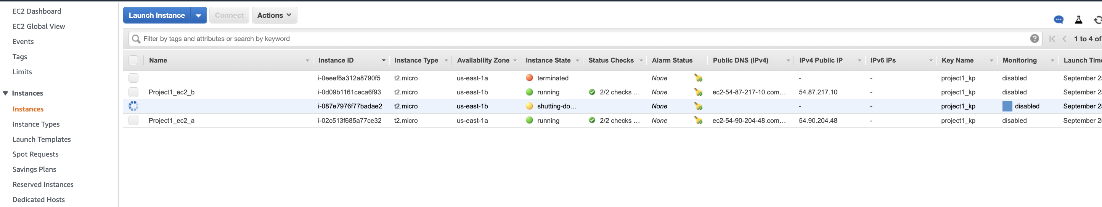

when terminated the instance a new instance got initiated.

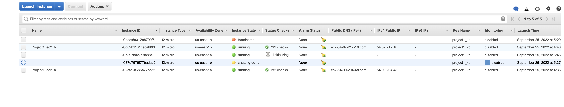

1. **Testing Load Balancer**: As load balancer’s task is to balance the traffic load coming to application, whenever we hit the load balancer URL it calls instance one by one.

It shows the user data and instance id used for Instance1.

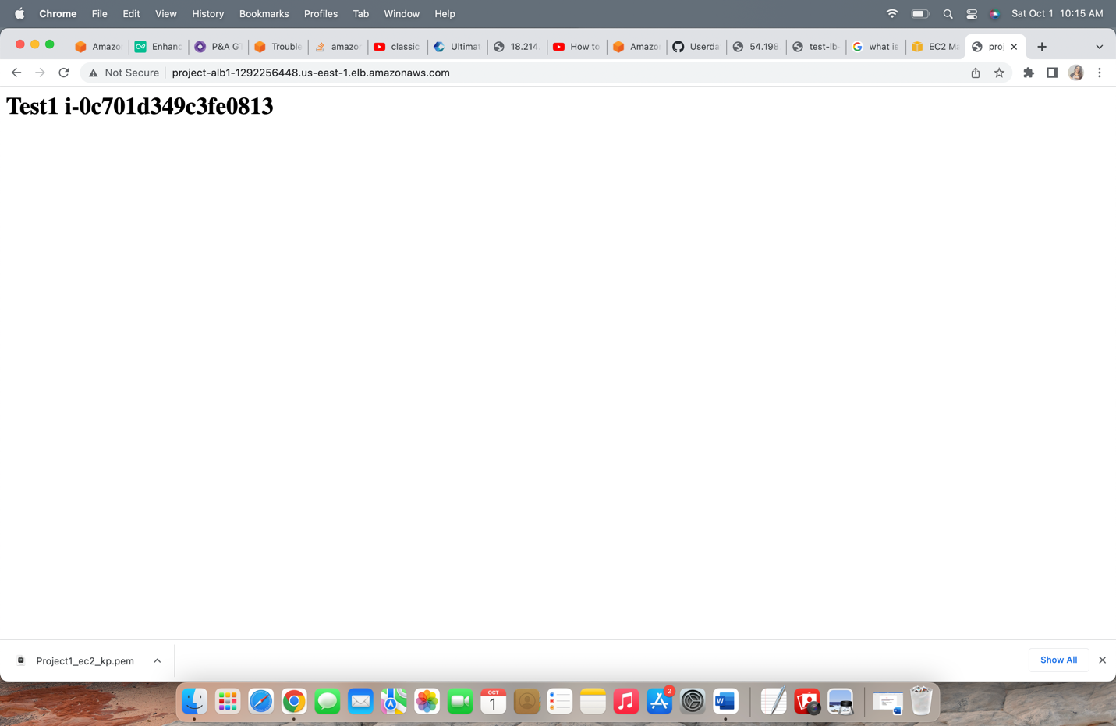

It shows the user data and instance id used for Instance2.

